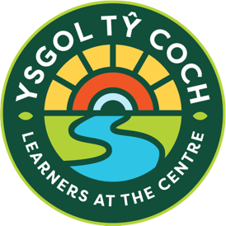
Tonteg Site
Lansdale Drive
Tonteg, Pontypridd
CF38 1PG
Telephone: 01443 203471
Buarth y Capel Site
Ynysybwl
Pontypridd
CF37 3PA
Telephone: 01443 203471

26 June 2026
Dear Parents/Carers,

We would like to inform you that on Wednesday, 15th July, we will be holding a special Celebration Festival in our Sensory Garden for our learners and staff to celebrate all the fantastic achievements and experiences we have shared throughout the year. It will also include a reflective time to remember a much-loved pupil we sadly passed away this year.
The festival will take place outdoors in our Sensory Garden regardless of the weather, so we kindly ask that you ensure your child comes to school dressed appropriately for the conditions on the day.
Pupils will have the opportunity to take part in a range of engaging activities across different themed zones, including:
- Music and Movement Zone
- Chill-Out Zone
- Glam Zone (face painting and glitter tattoos)
- Food Zone
If you would prefer your child not to take part in face painting or have glitter tattoos applied, please inform your child’s class teacher.
We will be ending the day with a fun and colourful Colour Run, so please ensure your child brings a spare change of clothes (ideally old clothes).
We are very much looking forward to what promises to be a positive, uplifting and memorable day for all our learners and staff.
Thank you for your continued support.

Yours sincerely,
Leigh Wharton

